Pixie Hollow – An e-Commerce website

Link: <http://pixiehollowvm-f4d2f6cf.eastus.cloudapp.azure.com/>

1. Home Page  
   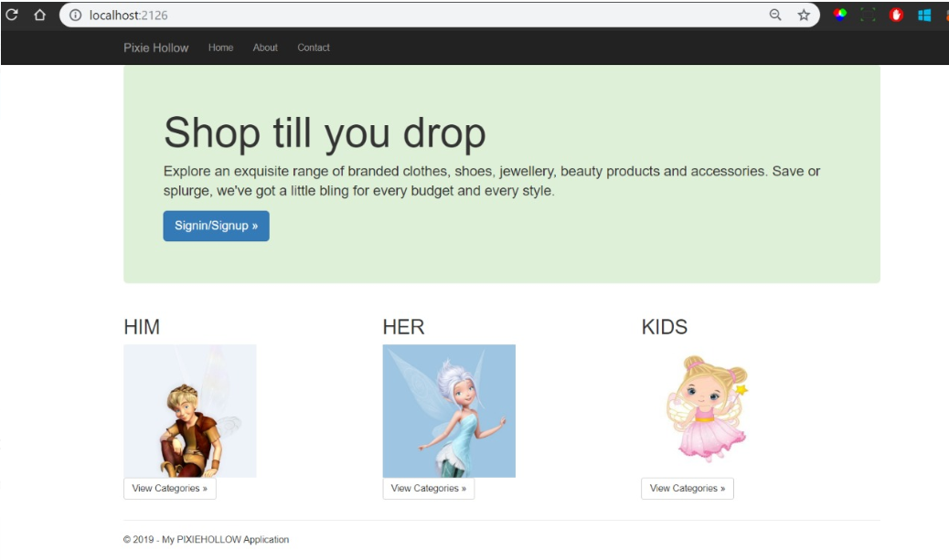
2. About  
   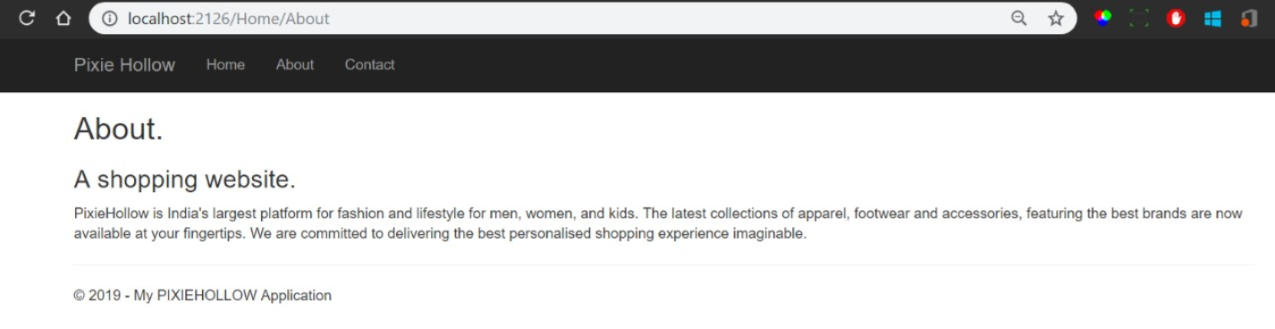
3. Contact  
   